Modified Boolean Retrieval:

Q1.TXT

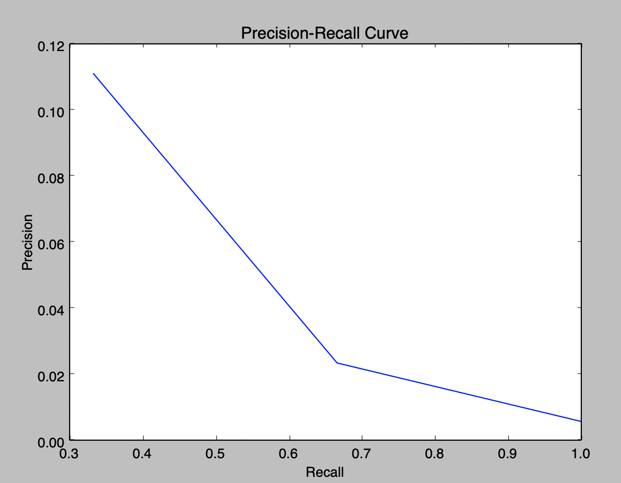

Position: 9

AF2: 0.208333333333

MAP: 0.111111111111

R-precision: 0.111111111111

===================

Position: 85

AF2: 0.154166666667

MAP: 0.0673202614379

R-precision: 0.0673202614379

===================

Position: 513

AF2: 0.112247474747

MAP: 0.0468294920307

R-precision: 0.0468294920307

Q2.txt

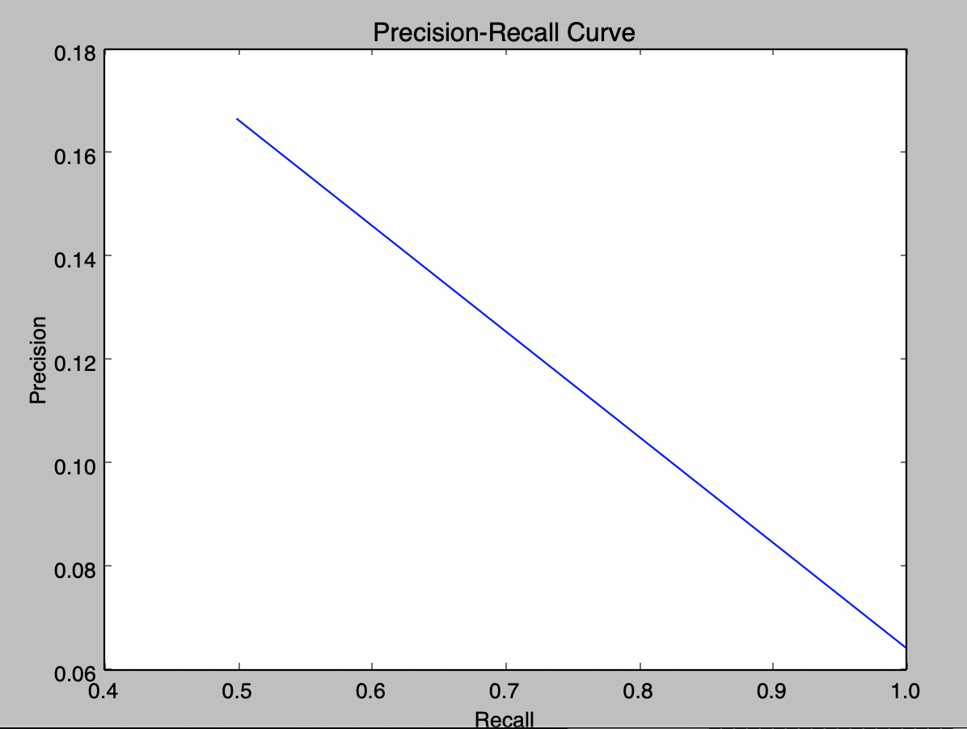

Position: 6

AF2: 0.3125

MAP: 0.166666666667

R-precision: 0.166666666667

===================

Position: 31

AF2: 0.278201219512

MAP: 0.115591397849

R-precision: 0.115591397849

===================

Q3.TXT

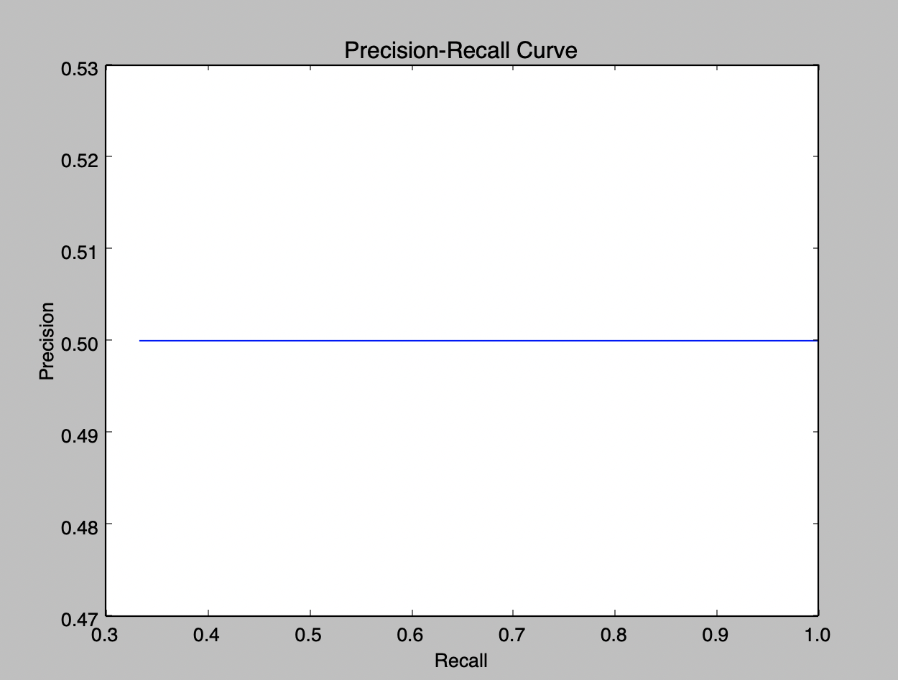

Position: 2

AF2: 0.294117647059

MAP: 0.5

R-precision: 0.5

===================

Position: 4

AF2: 0.410216718266

MAP: 0.5

R-precision: 0.5

===================

Position: 6

AF2: 0.511573050273

MAP: 0.5

R-precision: 0.5

BOOLEAN AS FREETEXT

Q1.txt

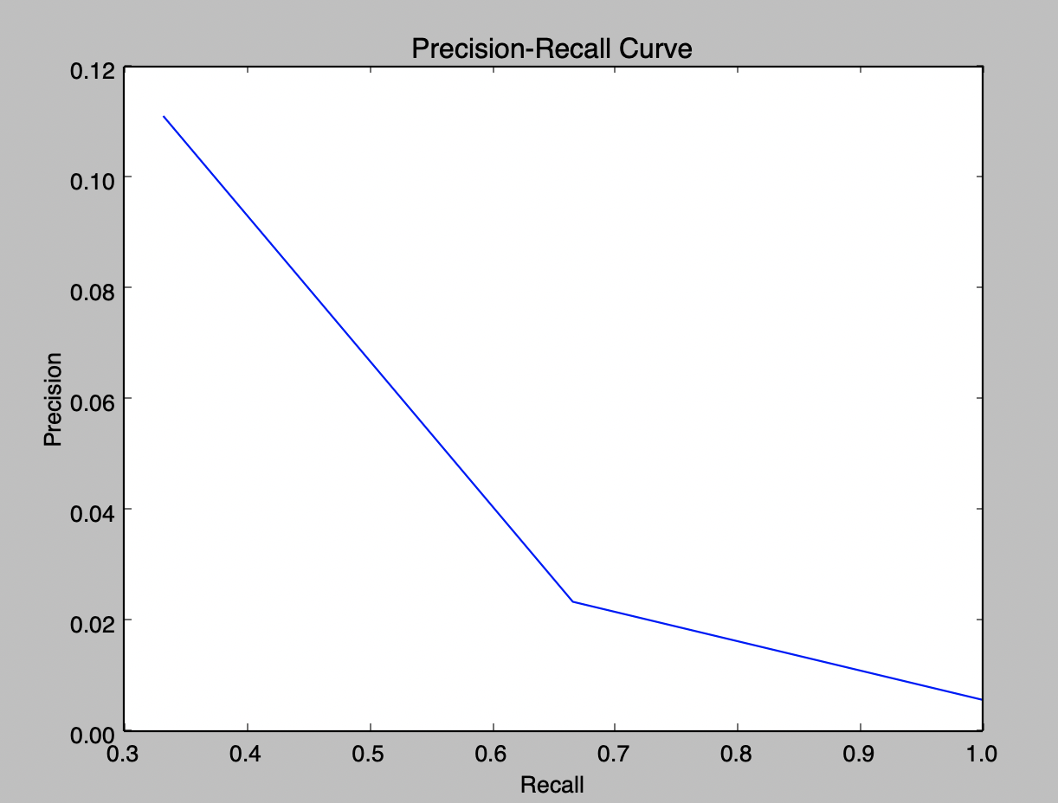

[6807771, 4001247, 3992148]

Position: 9

AF2: 0.208333333333

MAP: 0.111111111111

R-precision: 0.111111111111

===================

Position: 85

AF2: 0.154166666667

MAP: 0.0673202614379

R-precision: 0.0673202614379

===================

Position: 513

AF2: 0.112247474747

MAP: 0.0468294920307

R-precision: 0.0468294920307

Q2.txt

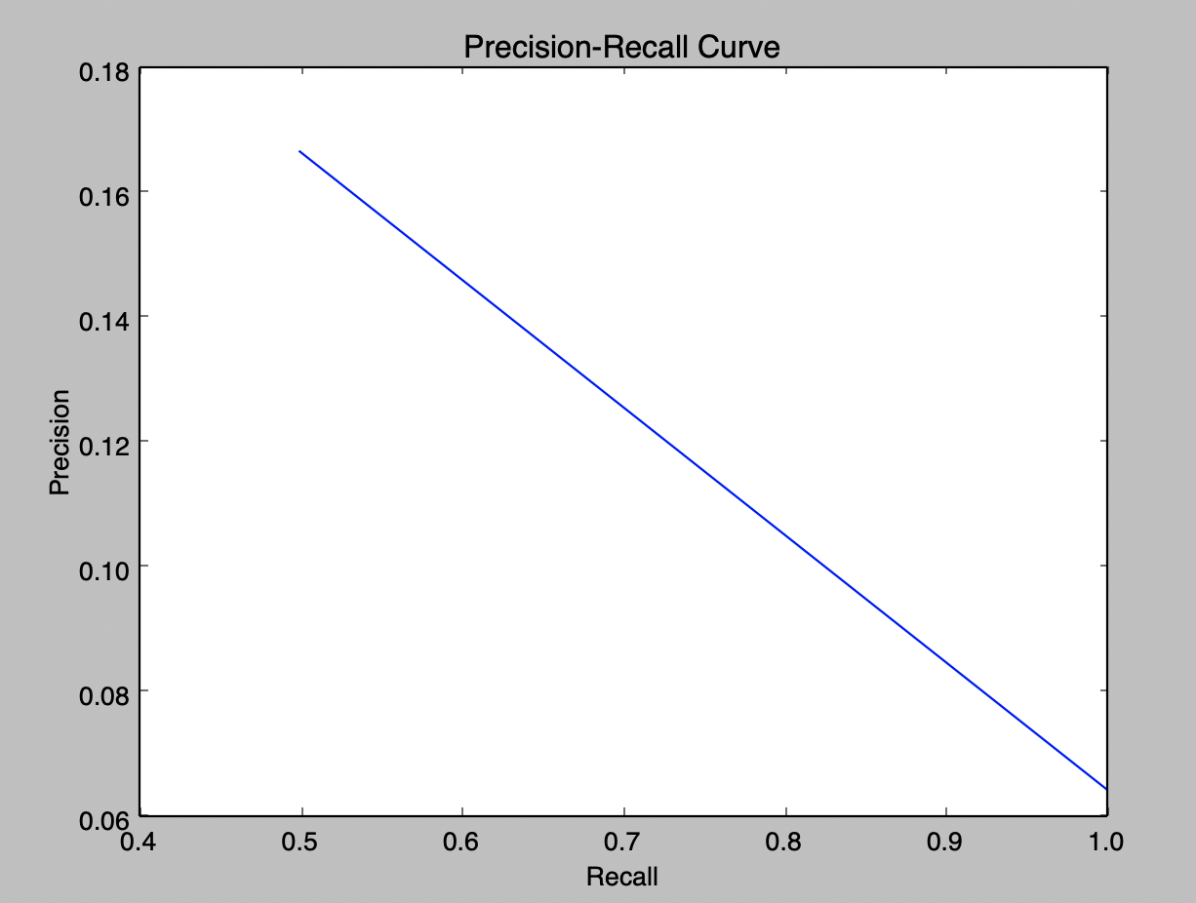

[2211154, 2748529]

Position: 6

AF2: 0.3125

MAP: 0.166666666667

R-precision: 0.166666666667

===================

Position: 31

AF2: 0.278201219512

MAP: 0.115591397849

R-precision: 0.115591397849

===================

Q3.TXT

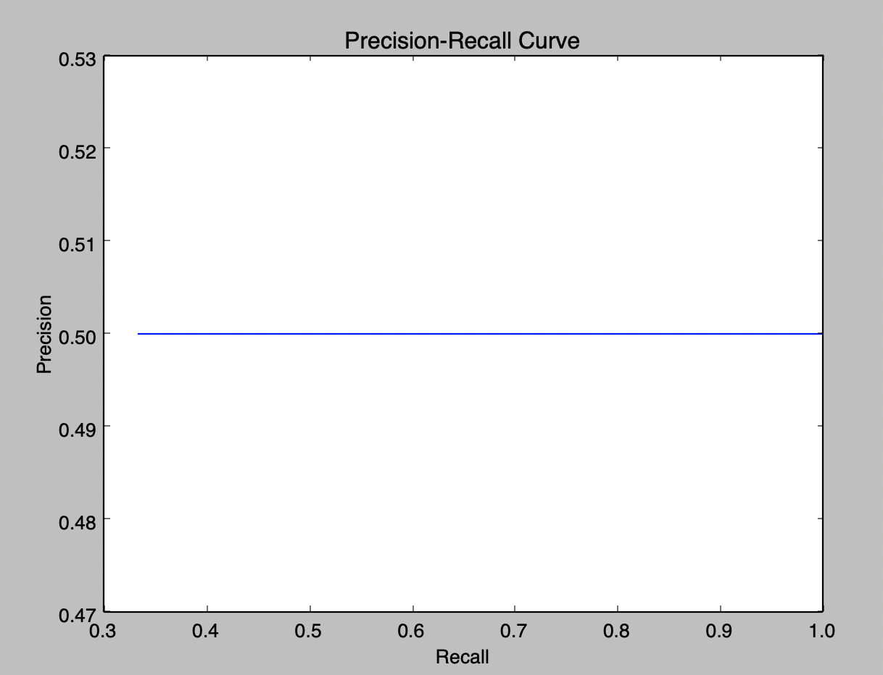

[4273155, 3243674, 2702938]

Position: 2

AF2: 0.294117647059

MAP: 0.5

R-precision: 0.5

===================

Position: 4

AF2: 0.410216718266

MAP: 0.5

R-precision: 0.5

===================

Position: 6

AF2: 0.511573050273

MAP: 0.5

R-precision: 0.5

Without Thesaurus(Boolean Freetext)

Q1.TXT

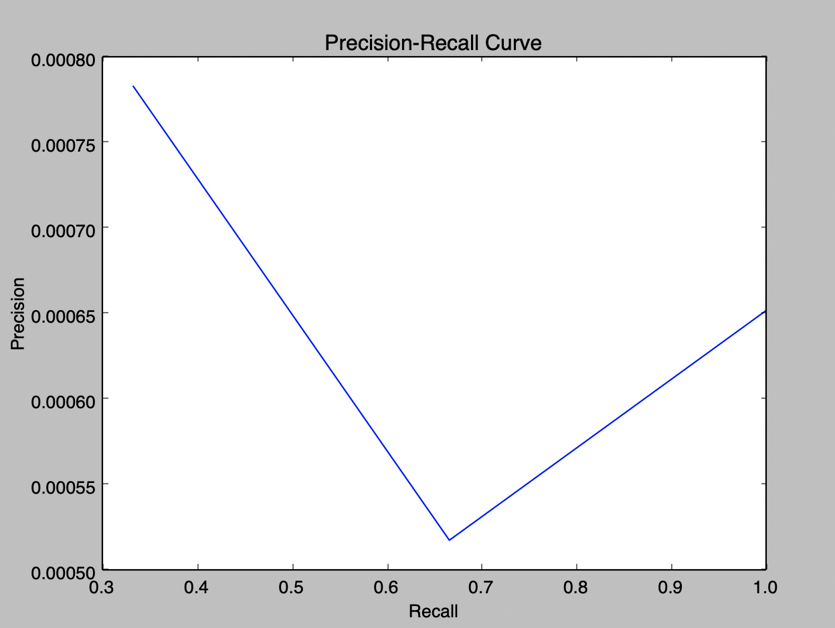

Execution Time:0.866503953934s

[6807771, 4001247, 3992148]

Position: 1276

AF2: 0.00386996904025

MAP: 0.000783085356304

R-precision: 0.000783085356304

===================

Position: 3862

AF2: 0.00322430891414

MAP: 0.000650408844344

R-precision: 0.000650408844344

===================

Position: 4602

AF2: 0.00323225906821

MAP: 0.000650855516042

R-precision: 0.000650855516042

===================

Q2.txt

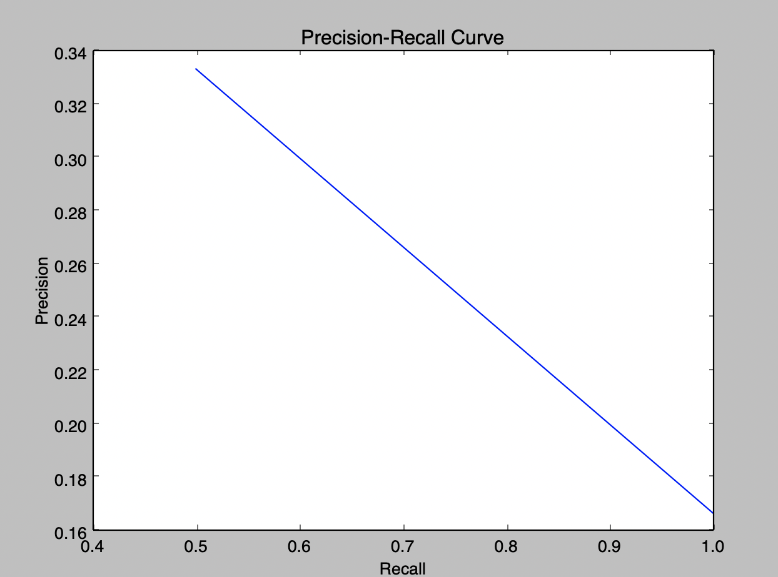

freetext['good', 'grades', 'exchange', 'scandal']

Execution Time:0.628773927689s

[2211154, 2748529]

Position: 2

AF2: 0.384615384615

MAP: 0.333333333333

R-precision: 0.333333333333

===================

Position: 11

AF2: 0.41958041958

MAP: 0.25

R-precision: 0.25

Q3.TXT

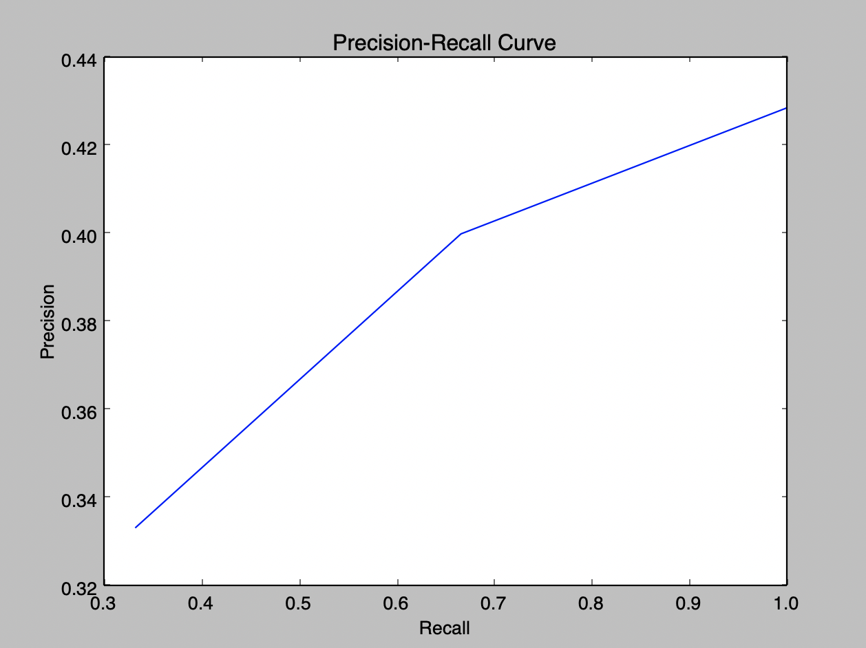

booleanQuery[['fertility', 'treatment'], 'damages']

Execution Time:0.556035995483s

[4273155, 3243674, 2702938]

Position: 2

AF2: 0.277777777778

MAP: 0.333333333333

R-precision: 0.333333333333

===================

Position: 4

AF2: 0.388888888889

MAP: 0.366666666667

R-precision: 0.366666666667

===================

Position: 6

AF2: 0.486531986532

MAP: 0.387301587302

R-precision: 0.387301587302

===================

Freetext Boolean with Stopwords removal

Q1.TXT

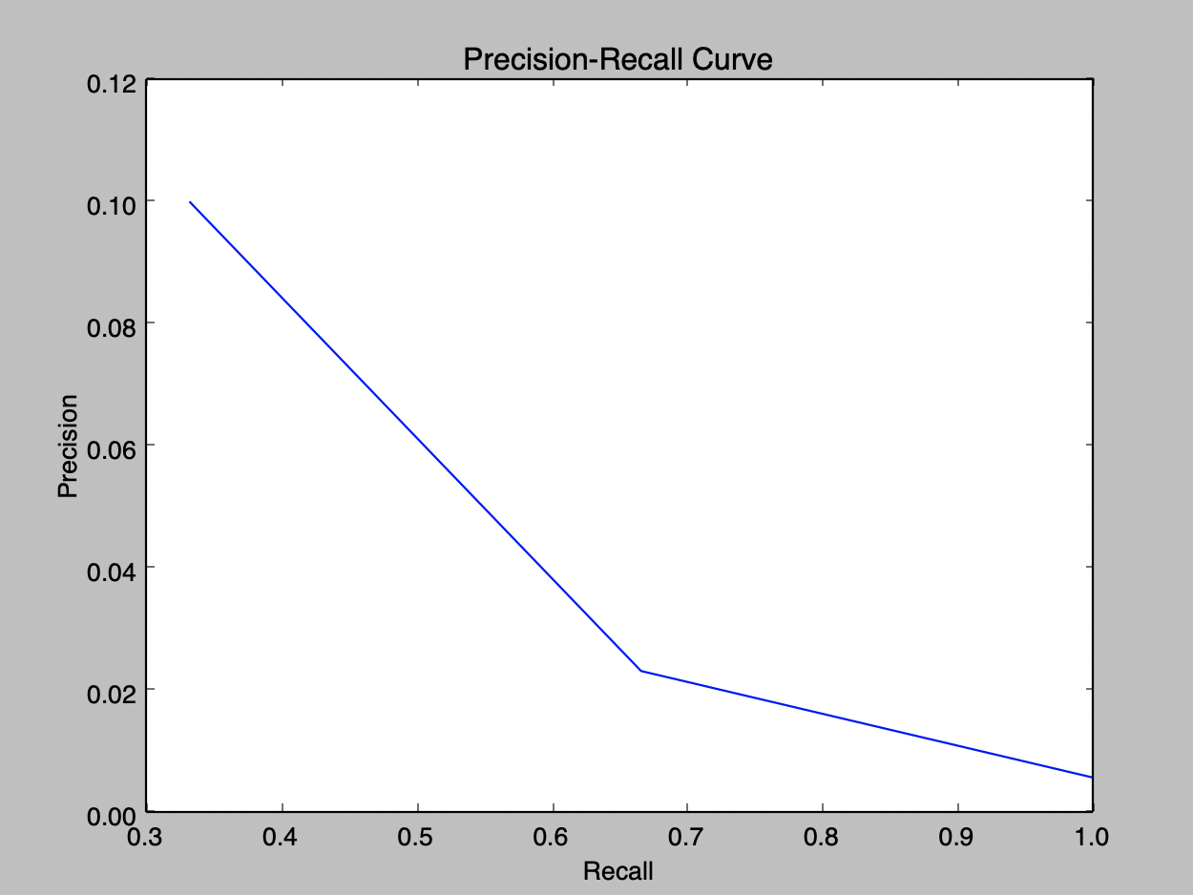

[6807771, 4001247, 3992148]

freetext['quiet', 'phone', 'call']

Execution Time:5.14295697212s

[6807771, 4001247, 3992148]

Position: 9

AF2: 0.2

MAP: 0.1

R-precision: 0.1

===================

Position: 85

AF2: 0.149504950495

MAP: 0.0616279069767

R-precision: 0.0616279069767

===================

Position: 513

AF2: 0.109121762838

MAP: 0.0430307966097

R-precision: 0.0430307966097

===================

Q2.TXT

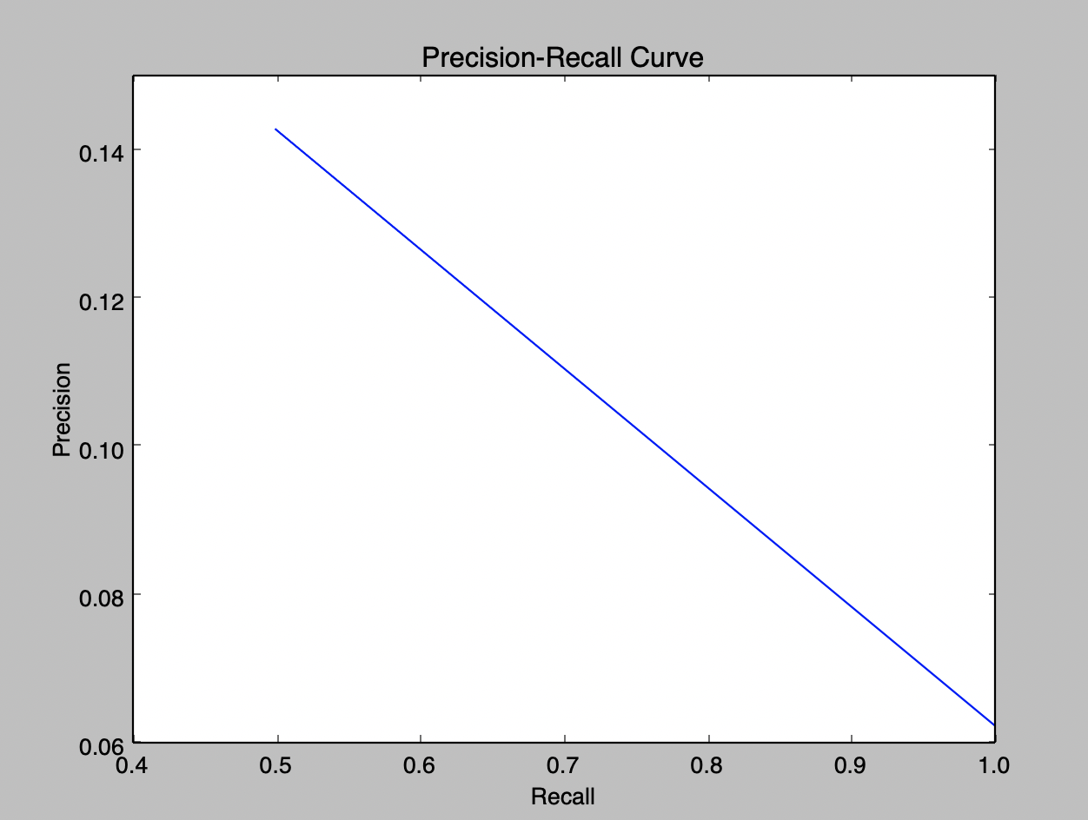

freetext['good', 'grades', 'exchange', 'scandal']

Execution Time:4.26952290535s

[2211154, 2748529]

Position: 6

AF2: 0.294117647059

MAP: 0.142857142857

R-precision: 0.142857142857

===================

Position: 31

AF2: 0.266106442577

MAP: 0.102678571429

R-precision: 0.102678571429

Q3.txt

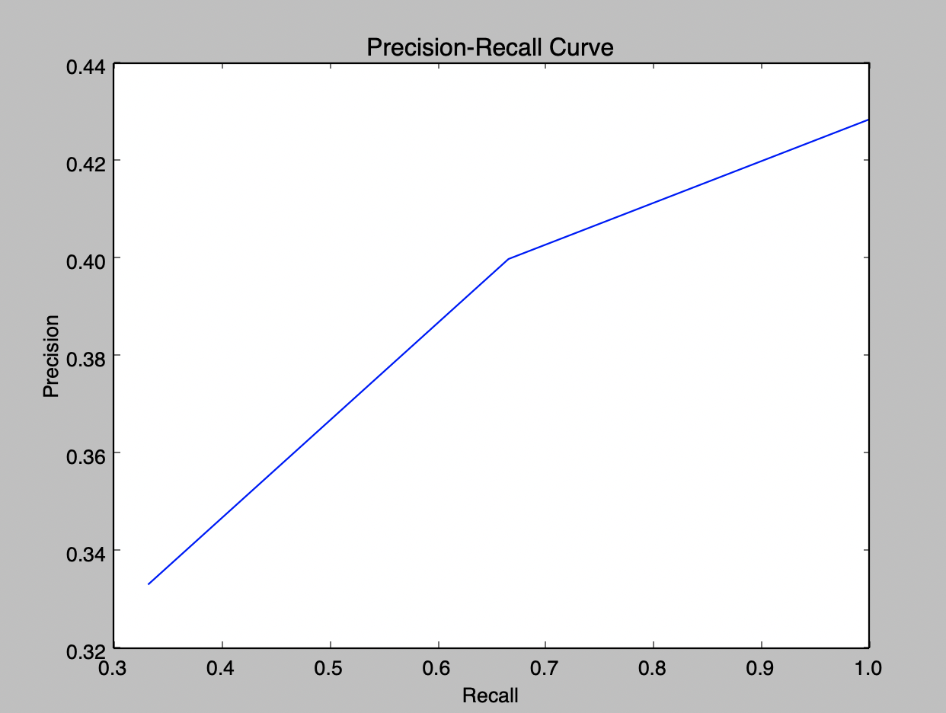

booleanQuery[['fertility', 'treatment'], 'damages']

Execution Time:3.69965982437s

[4273155, 3243674, 2702938]

Position: 2

AF2: 0.277777777778

MAP: 0.333333333333

R-precision: 0.333333333333

===================

Position: 4

AF2: 0.388888888889

MAP: 0.366666666667

R-precision: 0.366666666667

===================

Position: 6

AF2: 0.486531986532

MAP: 0.387301587302

R-precision: 0.387301587302

===================

Thesaurus(without lexn algo)

Q1.TXT

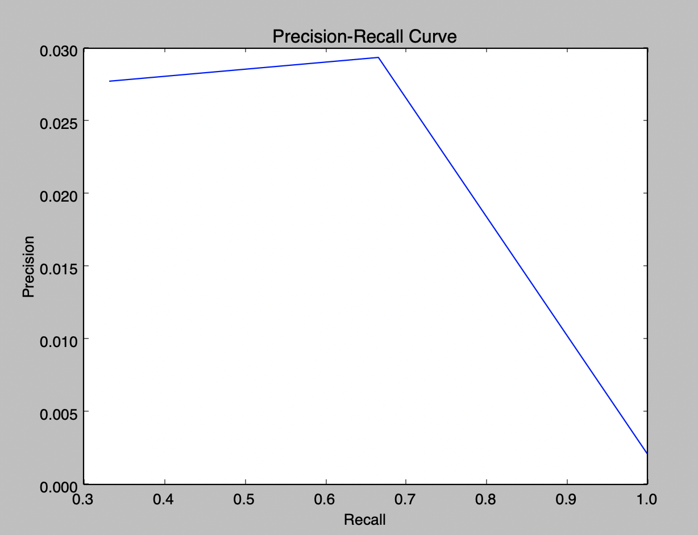

freetext['quiet', 'phone', 'call']

Execution Time:5.67965102196s

[6807771, 4001247, 3992148]

Position: 36

AF2: 0.0961538461538

MAP: 0.027027027027

R-precision: 0.027027027027

===================

Position: 68

AF2: 0.107600732601

MAP: 0.0280062671367

R-precision: 0.0280062671367

===================

Position: 1369

AF2: 0.0753439300371

MAP: 0.0194007717651

R-precision: 0.0194007717651

===================

Q2.TXT

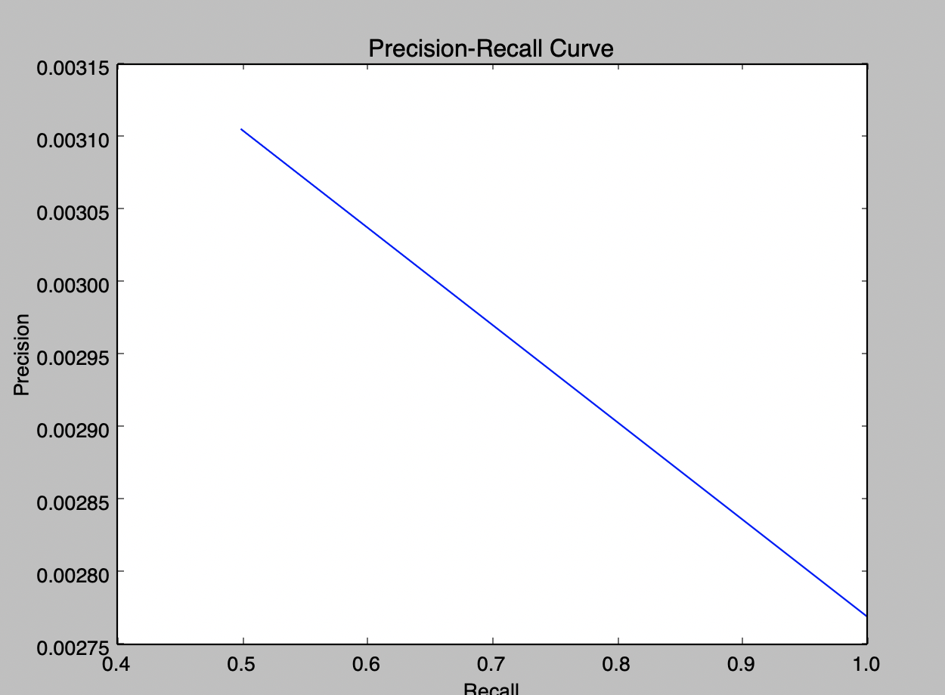

freetext['good', 'grades', 'exchange', 'scandal']

Execution Time:15.0721790791s

[2211154, 2748529]

Position: 321

AF2: 0.0150602409639

MAP: 0.00310559006211

R-precision: 0.00310559006211

===================

Position: 721

AF2: 0.0143607215748

MAP: 0.0029378365823

R-precision: 0.0029378365823

===================

Q3.TXT

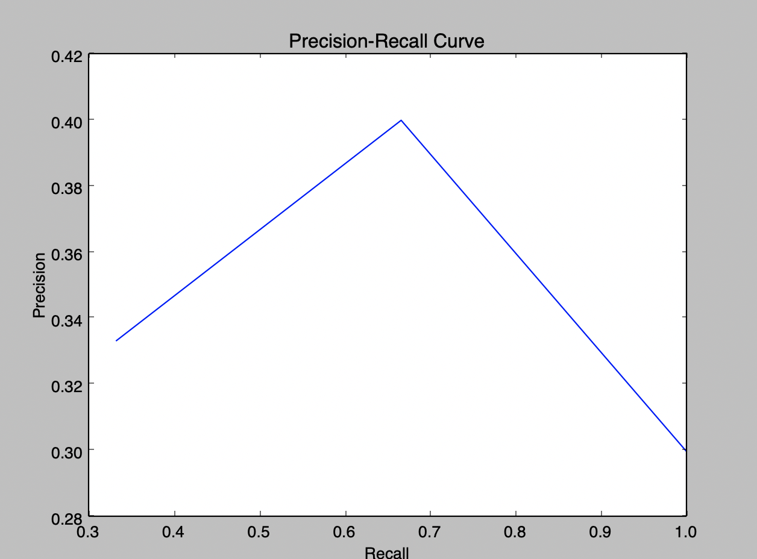

booleanQuery[['fertility', 'treatment'], 'damages']

Execution Time:5.9614379406s

[4273155, 3243674, 2702938]

Position: 2

AF2: 0.277777777778

MAP: 0.333333333333

R-precision: 0.333333333333

===================

Position: 4

AF2: 0.388888888889

MAP: 0.366666666667

R-precision: 0.366666666667

===================

Position: 9

AF2: 0.459259259259

MAP: 0.344444444444

R-precision: 0.344444444444

===================

**WITH PRF**

**Q1.txt**

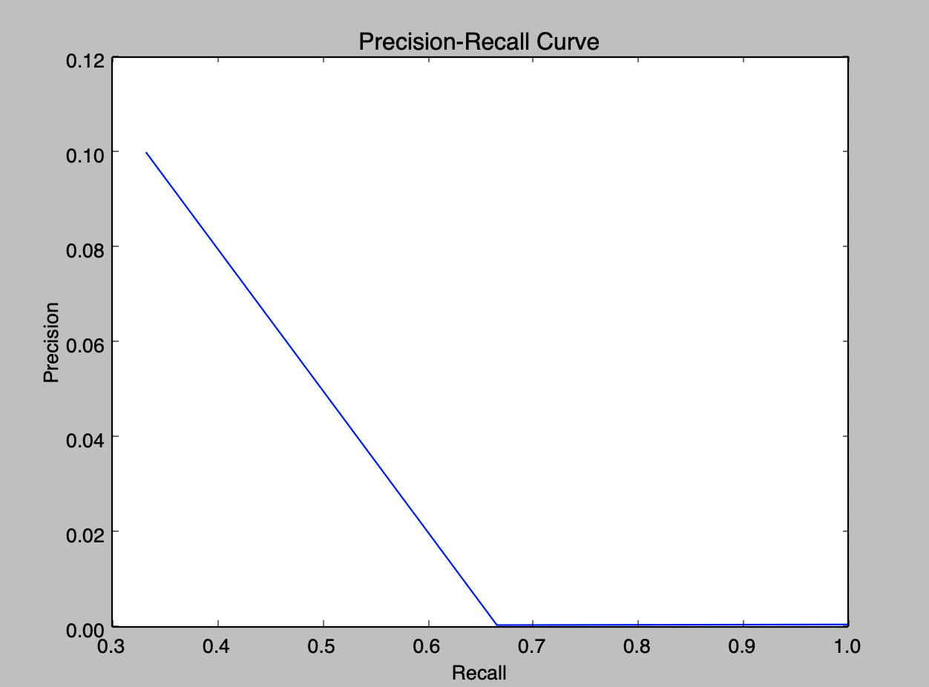

freetext['quiet', 'phone', 'call']

Execution Time:12.4646420479s

[6807771, 4001247, 3992148]

Position: 9

AF2: 0.2

MAP: 0.1

R-precision: 0.1

===================

Position: 3694

AF2: 0.101347708895

MAP: 0.0502706359946

R-precision: 0.0502706359946

===================

Position: 4494

AF2: 0.0686737867134

MAP: 0.0337362267402

R-precision: 0.0337362267402

===================

Q2.txt

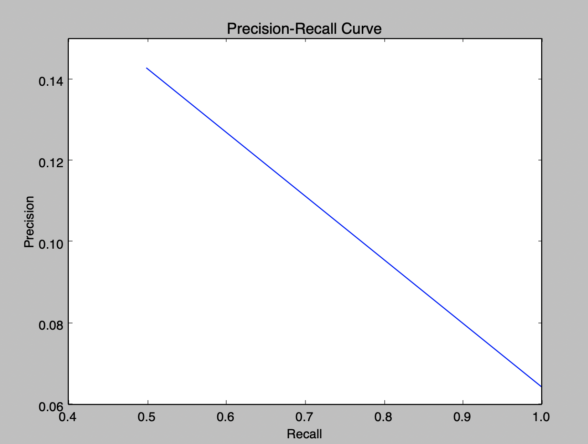

freetext['good', 'grades', 'exchange', 'scandal']

Execution Time:9.78571891785s

[2211154, 2748529]

Position: 6

AF2: 0.294117647059

MAP: 0.142857142857

R-precision: 0.142857142857

===================

Position: 30

AF2: 0.269010043042

MAP: 0.103686635945

R-precision: 0.103686635945

===================

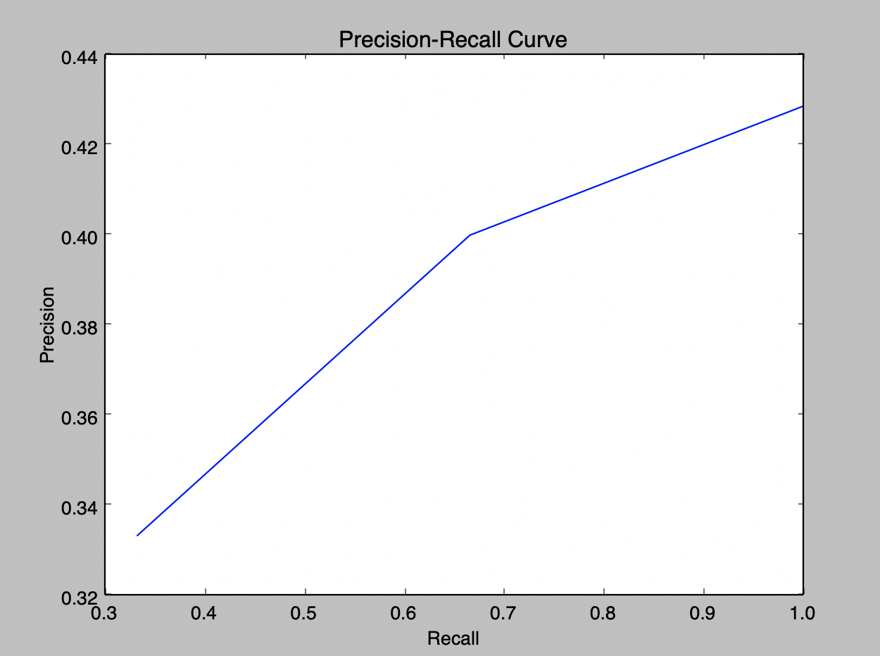

booleanQuery[['fertility', 'treatment'], 'damages']

Execution Time:10.0291559696s

[4273155, 3243674, 2702938]

Position: 2

AF2: 0.277777777778

MAP: 0.333333333333

R-precision: 0.333333333333

===================

Position: 4

AF2: 0.388888888889

MAP: 0.366666666667

R-precision: 0.366666666667

===================

Position: 6

AF2: 0.486531986532

MAP: 0.387301587302

R-precision: 0.387301587302

===================

Mixture model

freetext['quiet', 'phone', 'call']

Execution Time:4.35599589348s

[6807771, 4001247, 3992148]

Position: 9

AF2: 0.2

MAP: 0.1

R-precision: 0.1

===================

Position: 85

AF2: 0.149504950495

MAP: 0.0616279069767

R-precision: 0.0616279069767

===================

Position: 513

AF2: 0.109121762838

MAP: 0.0430307966097

R-precision: 0.0430307966097

BJ-MacBook-Pro:HW4 boonjun$ python evaluation.py -d dictionary.txt -p postings.txt -r queries/q2.txt

freetext['good', 'grades', 'exchange', 'scandal']

Execution Time:4.20502901077s

[2211154, 2748529]

Position: 6

AF2: 0.294117647059

MAP: 0.142857142857

R-precision: 0.142857142857

===================

Position: 31

AF2: 0.266106442577

MAP: 0.102678571429

R-precision: 0.102678571429

BJ-MacBook-Pro:HW4 boonjun$ python evaluation.py -d dictionary.txt -p postings.txt -r queries/q3.txt

booleanQuery[['fertility', 'treatment'], 'damages']

Execution Time:3.61441707611s

[4273155, 3243674, 2702938]

Position: 2

AF2: 0.277777777778

MAP: 0.333333333333

R-precision: 0.333333333333

===================

Position: 4

AF2: 0.388888888889

MAP: 0.366666666667

R-precision: 0.366666666667

===================

Position: 6

AF2: 0.486531986532

MAP: 0.387301587302

R-precision: 0.387301587302

0.5574074033

0.08337321791

References:

<http://delivery.acm.org.libproxy1.nus.edu.sg/10.1145/190000/188559/p212-turtle.pdf?ip=137.132.123.69&id=188559&acc=ACTIVE%20SERVICE&key=FF6731C4D3E3CFFF%2EBB5EB8D2067C1662%2E4D4702B0C3E38B35%2E4D4702B0C3E38B35&__acm__=1555709943_a40e17f4ad2df64627131565801c5300>

Natural Language vs Boolean query performance